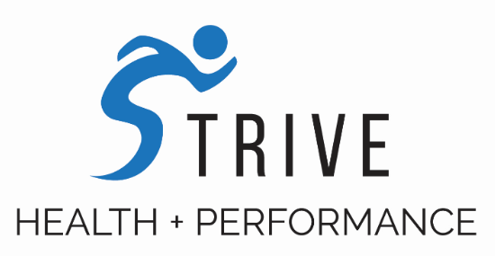

Concussions and Proper Management
Mild traumatic brain injury = concussion (no actual brain damage); moderate/severe brain injury = brain damage.
Concussions are due to forces of acceleration which cause sheering/stretching of brain tissue. This results in millions of nerves firing (sending signals) which uses up excessive amounts of brain energy. This energy consumption continues over the next few days resulting in an energy deficit. This is why most people feel tired and lethargic the days following a concussion. Normal brain energy levels take 2-4 weeks to restore. Symptoms typically resolve within 7-10 days but this DOES NOT mean the brain has fully recovered. Other deficits such as reaction time, coordination, balance, etc still exist which make the athlete more susceptible for another concussion. If someone receives a second concussion before they have fully recovered from their previous concussion, they risk long term and/or permanent brain damage, and possibly death. If you fully recover from your concussion and later receive another concussion (and recover fully), there is no difference in the CT/MRI of their brain compared to before they had any concussions. Therefore, CONCUSSIONS AREN’T THE PROBLEM, IMPROPER MANAGEMENT OF CONCUSSIONS ARE THE PROBLEM.
Our biggest problem in concussion management is allowing athletes to return to play before they have actually fully recovered. We CANNOT rely on symptoms alone as our measuring tool for return to play. Refer the athlete to a certified specialist in concussion management to assess and manage the injury.
Some common signs and symptoms at the time of injury: headaches, nausea, dizziness, loss of consciousness, loss of coordination/balance, confusion, amnesia, fatigue.
Red flags which indicate sending the athlete to the hospital: Severe or worsening headache, very drowsy or can’t be awakened, seizures, decreasing level of consciousness (more than 2 hours after injury), unusual behavior, very confused, very irritable, weakness or numbness in arms or legs, vomiting, unsteady on feet or slurred speech

What to do with a suspected injury:
-Assess the mechanism of injury
- Ask questions: what’s your name (always first questions)? where are we (what venue)? what half is it? who scored last in this match? What team did we play last week/game? Did we win our last game?
- If no symptoms and can answer all the questions, it’s ok to continue playing
- If symptoms, then pull from the game; have them sit in the shade and cool body temperature if you can this decreases chemical release which decreases the neurological dysfunction
- Monitor for 2-3 hours and don’t let them sleep
- Parents wake them up every 2 hours that night ask questions and ensure there’s no increase in neurological dysfunction
- Refer to us within 24 hours for assessment Proper management is key!

Can we treat a concussion???
Yes, there are lots of areas to treat depending on what is causing the symptoms. Rest is needed for 2-3 days. However, prolonged rest has been shown to prolong symptoms.
Types of Treatment:
  - Manual Therapy - Concussion = Whiplash. We can treat the neck.
  - Exercise Therapy – Blood flow abnormalities. Implement specific exercise protocols to increase blood flow to the brain to stimulate healing.
  - Nutrition – dietary changes in order to decrease inflammation in the brain = speed metabolic recovery!
  - Vestibular Therapy - Balance & Coordination issues
  - Visual Therapy – Visual issues

Performing baseline assessments when an athlete is healthy will provide us with a reliable measuring tool as to when concussed athletes’ brains have fully recovered. When they reach their pre-injury baseline scores, we can safely clear them to return to play.

If you have any questions, please contact Dr. Aaron Binstock at drbinstock@strivehealthandperformance.ca

